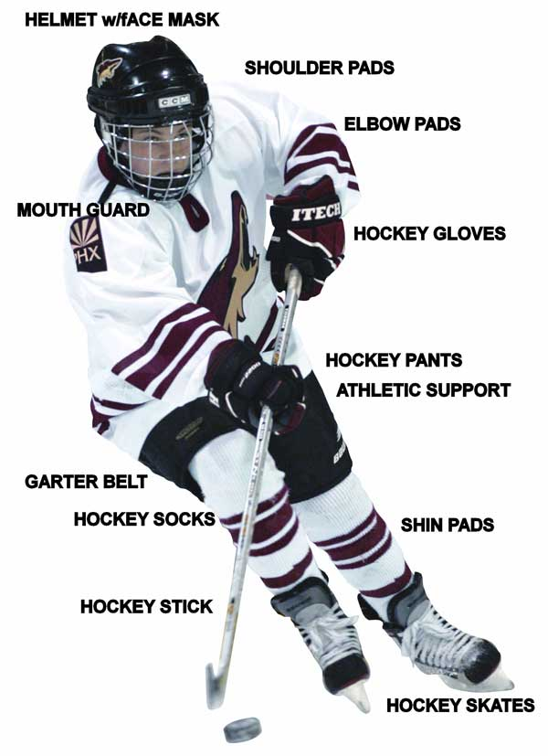

Need help protecting your player?
Not sure what they need?
Not sure how it should fit?

All equipment should fit properly and be worn properly to provide maximum protection for your hockey player.

Helmet with Face Shield/Cage - Mouth Guard - Neck Guard -
Shoulder Pads - Elbow Pads - Hockey Jock - Hockey Pants
Shin Guards - Hockey Socks - Practice Jersey - Gloves - Skates - Stick

