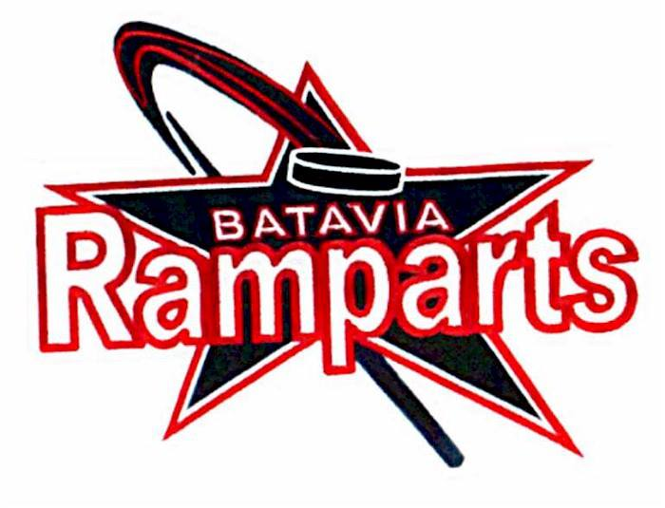
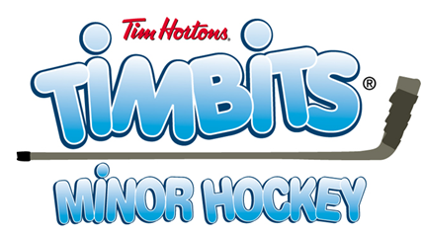

It’s time to learn to play HOCKEY! Genesee Amateur Hockey Association (GAHA) is proud to offer its Beginner Program sponsored by Tim Hortons to your child.

Location: David M. McCarthy Memorial Ice Arena in Batavia (Evans St. attached to the Fire Department)

Cost: $125 per skater for Session I and $75 per skater for Session II or a total of $200 (If your child does not participate in Session I, the fee would be $125 per skater for Session II).

Session I: The first ice time will be first week of October (TBA). Session II will begin after New Year’s Day (The schedule will be every Saturday first timeslot and another day during the week – about every other week) at 5 p.m.
Tim Horton jerseys will be handed out at the first ice session in October – please arrive at the rink a half-hour before the scheduled time if possible. For Session II – Please also arrive a bit earlier. If the jerseys arrive prior to the Orientation, we will start handing them out at that event. An Orientation is tentatively planned the last week of September – watch for an email announcement.

A schedule will be available in late September/early October

Parents are asked to sit in the bleachers during practices. No one is allowed on the player benches – this is for everyone’s safety.

How to Register:
Step 1:
Register with USA Hockey online at www.usahockeyregistration.com. Effective for the 2022-23 Hockey Year there is a fee for registering with USA Hockey. Have your credit card handy to make USA Hockey Registration payment.
2016 & Younger $15.00
2015-2014 $50.00
2013-2010 $61.00
2009-2004 $70.00
Retain a copy of your USA Hockey confirmation number and forward to Barnes.marcia21@gmail.com

Step 2:
Each player must also register with GAHA online at
https://bataviaramparts.leagueapps.com/clubteams/4254730-batavia-ramparts-2024-2025-hockey-registrations
ou will need your USA Hockey confirmation number to begin the process. Instructions for registering with GAHA are on the front page of the website.

** If you are having difficulty registering with either USA Hockey or GAHA, contact GAHA Registrar – Allyson Valyear at bramparts@gmail.com

Step 3:
Hockey fees are due prior to your player’s first ice. You can make payment on the GAHA website when you register your player or you can pay at the rink by putting a check or cash into the lock box located under the mailboxes in the Conference Room. You can also mail payment to GAHA / P.O. Box 9 / Batavia NY 14021-0009. Checks should be made out to GAHA. Please include a note with player name and denote “Beginner” for accounting ease New for 2024-25 season you can also pay via Venmo @GAHA-Hutchins.
** Players must be registered with USA Hockey and GAHA prior to October 1st or January 2nd (Session II) in order to take the ice. Ice fees must be paid as well by October 1st or January 2nd (Session II).

See the GAHA website for information on required equipment needs and other useful information. Please contact Marcia Barnes, Beginner Player Coordinator at Barnes.marcia21@gmail.com or 585-409-1383. If you are interested in being an on-ice Coach or Helper, contact Marcia with any questions you might have.

Marcia Barnes Sharon Valyear-Gray
Beginner Player Coordinator Beginner Program Coordinator
585-409-1383 585-344-2248
Barnes.marcia21@gmail.com svgray@rochester.rr.com

Last updated on 7/29/2026

